OSMAN FARUK VERİMER PRIMARY SCHOOL’S
E-SAFETY POLICY AND ACTIVITIES

OSMAN FARUK VERİMER PRIMARY SCHOOL e-SAFETY POLİCY

Policy Objectives and Policy Scope

- Osman Faruk Verimer Primary School believes that online security (e-Security) is an indispensable element for the protection of children and adults in the digital world while using technology such as computers, tablets, mobile phones or game consoles.

- Osman Faruk Verimer Primary Schoolbelieves that internet and information communication technologies are an important part of daily life. Therefore, students should be supported to learn how to manage risks and develop strategies to respond to them.

- Osman Faruk Verimer Primary Schoolis obliged to provide high quality internet access in order to raise the standards of education, promote success, support the professional work of the staff and improve the management functions.

- Osman Faruk Verimer Primary Schoolis responsible for ensuring that all students and staff are
protected online from potential damages.

- This policy is intended for administrators, teachers, support staff, students and parents.

- This policy applies to the use of communication devices, including internet access and personal devices; This includes devices provided by the school for remote use, such aslaptops, tablets or mobile devices where students, staff or other people work.

Responsibilities of the School Administration, Teachers and Other Support Staff

- Contribute to the development of online security policies.

- Read and adhere to Acceptable Use Policies.

- Be responsible for the security of school systems and data. Protect all students, parents, teachers and other personnel data, passwords, etc. by means of clouds.

- To be aware of online security and to know how they can relate to students in their care.

- Model good practices when new and emerging technologies are used.

- Associate curriculum and online safety training as much as possible.

- Identifying and taking action by monitoring school protection policies and procedures.

- Emphasis on safe and positive learning opportunities.

- To take personal responsibility for professional development in this field.

The main responsibilities of students are:

- Contribute to the development of online security policies.

- Read and adhere to Acceptable Use Policies.

- Respect the feelings and rights of others, online and offline.

- If things go wrong, seek help from a trusted adult and support others who are
experiencing online security issues.

- Take responsibility to protect themselves and others online.

- To be responsible for their own awareness and learning about the opportunities and risks of new
and emerging technologies.

The main responsibilities of the parents are:

- Reading School Acceptable Use Policies, encouraging children to adhere to this policy and
ensuring that they adhere to them as appropriate.

- Discuss online safety issues with your children, support the school's online safety approaches, and reinforce appropriate safe online behavior at home.

- Modeling the safe and appropriate use of technology and social media.

- Identify changes in behavior that indicate that the child is at risk of harm online.

- Seek help or support from the school or other appropriate institution if your children encounter problems online.

- Contribute to the creation of the school's online security policies.

- Safe and appropriate use of school systems such as learning platforms and other network
resources.

Managing the school website

- The contact details on the website will be the school address, e-mail and telephonenumber. Personal information of staff or students will not be published.

- The Principal will assume the overall publication responsibility for the published online content and ensure that the information is accurate and appropriate.

- The website will comply with the school's publication guidelines, including accessibility, respect
for intellectual property, privacy policies, and copyright.

- To protect against spam emails, email addresses will be published online carefully.

- Student studies will be published both with the permission of the students and with the permission of their parents.

- The administrator account of the school website will be protected by being properly encrypted with a strong password.

Publish images and videos online

- The school will ensure that all pictures and videos shared online are used in accordance with the
school official use policy.

- The school will ensure that all pictures and videos are contained in accordance with other policies and procedures, such as data security, Acceptable Use Policies, Code ofConduct, social media, use of personal devices and mobile phones.

- In accordance with the image policy, parents 'written consent will always be obtained prior to electronic publication of students' pictures / videos.
Official video conferencing and webcam use for educational purposes.

- The school recognizes that video conferencing is a challenging activity with a wide range of learning advantages. Preparation and evaluation are required for the whole activity.

- All video conferencing equipment will be turned off when not in use and appropriate, not set to
auto-answer.

- External IP addresses will not be available to other sites.

- Video conference communication details will not be publicly shared.

- Video conferencing equipment will be securely held and, if necessary, locked when not in use.

- Staff will ensure that external video conferencing opportunities and / or tools are properly assessed and ensure that accounts and systems used to access events are appropriately safe and confidential.

Users

- Students will ask a teacher for permission before preparing or replying to a video conference call or message.

- Video conferencing will be appropriately supervised for students' age and ability.

- Parents' consent will be obtained before the students participate in the video conference
activities.

- Video conference will take place through formal and approved communication channels following a sound risk assessment.

- Only master managers will be granted access to the video conference management areas or
remote control pages.

- Private login and password information for educational video conferencing services will be provided to staff only and will be kept confidential.

Content

- When recording a videoconferencing course, written permission will be obtained from all sites and participants. The reason for recording should be specified at the beginning of the conference and the video conference recording should be open to all parties. The recordedmaterials will be stored safely.

- If third-party materials are to be included, the school will check whether this record isacceptable to avoid infringing the third party's intellectual property rights.

- The school will dialogue with other conference participants before attending a video conference.
If it is not the school, the school will check that it has received the material appropriate for the class.

Convenient and safe use of the Internet and related devices

- The use of the Internet is an important feature of educational access, and all students will receive appropriate age and ability to support and assist them in developing strategies to address their problems as part of the integrated school curriculum.

- The school's Internet access will be designed to develop and expand education.

- Internet access levels will be reviewed to reflect curriculum requirements and students' age and abilities.

- All school equipment will be used in accordance with the School's Acceptable Use Policy and
appropriate safety precautions.

- Students will be trained on the effective use of internet research, including skills in positioning, retrieving, and evaluating information.

- The school will ensure that staff and students comply with the copyright laws of materials
derived from the Internet and accept their sources of information.

- Evaluation of online materials is part of teaching and learning in all subjects and is seen as a whole in the curriculum.

Use of Personal Devices and Mobile Phones

- The use of mobile phones and other personal devices by students and adults will be agreed by the school and the school will take part in appropriate policies, including Acceptable Use or Mobile Phone Policy.

- Osman Faruk Verimer Primary Schoolis aware that personal communication with mobile technologies is an accepted part of daily life for students, staff and parents; however, it requires the safe and proper use of such technologies at school.

- Use of personal devices and mobile phones shall be carried out in accordance with the law and
other appropriate school policies.

- Abuse or the sending of inappropriate messages or content by mobile phones or personal devices is prohibited by any member of the community and any violation is treated as part of its disciplinary / behavioral policy.

- All members of the Osman Faruk Verimer Primary Schoolcommunity are encouraged to take steps to protect their mobile phones or devices from loss, theft or damage.

- Passwords and pin numbers must be kept confidential. Mobile phones and personal devices
should not be shared.

Students' use of personal devices and mobile phones

- Our students are not allowed to bring mobile phones to the school.
- The use of students' mobile phones or personal devices at the educational event will only take
place when approved by the school administration.
- When a student needs to call their parents, they are allowed to use the school phone.
- Students should give their phone numbers only to trusted friends and family members.

Personnel use of personal devices and mobile phones

- Staff can't use mobile phones to take photos or videos of students.
phones, tablets, or cameras, and use only the equipment provided for this purpose.

- Staff do not use any personal devices directly with students and use only the equipment
provided by the school during the course / training activities.

- Staff will ensure that any use of personal telephones and devices is always carried out in accordance with data protection and relevant school policies and procedures.

- Personnel, personal mobile phones and devices are switched off / in silent mode during class
hours.

- Bluetooth or other forms of communication must be "hidden" or turned off during class hours.

- In case of emergency, personal mobile phones or devices may not be used during the school
term unless authorized by the school administration.

- Disciplinary action is taken if a staff member violates school policy.

- Any claim involving personal use of staff's mobile phones or devices will be responded to by
following the school management policy.

Education of Students

- An online security (e-Security) curriculum is created and included throughout the school to raise awareness among students of the importance of safe and responsible internet use.

- Training on safe and responsible use will take place prior to internet access.

- Student contributions will be sought when writing and developing school online security policies and practices, including curriculum development and implementation.

- Students will be supported to read and understand the Acceptable Use Policy in accordance with
their age and abilities.

- Acceptable Use expectations and Posters will be published in all rooms with Internetaccess.

- Safe and responsible use of the Internet and technology will be strengthened in the curriculum
and in all matters.

- The school will reward students when they use technology positively.

- The school will implement peer education to improve online safety in line with the needs of the
students.

Staff Training
- Online security (e-Security) policy will be formally provided and discussed for the participation of all employees and will be strengthened and emphasized as part of our protection responsibility.

- Personnel will be aware that Internet traffic can be monitored and tracked to a single user.
Discretion and professional behavior are required when using school systems and devices.

- Up-to-date and appropriate staff training on safe and responsible Internet use will be provided to all members of staff in a variety of ways on a regular (at least annual) basis.

Parents' Education

- Osman Faruk Verimer Primary School acknowledges that parents have an important role to play in order for children to become reliable and responsible users of the Internet and digital technology.

- Parents' attention will be directed to school online security (e-Security) policy and expectations on the school descriptions and school website.

- Parents will be encouraged to read the School's Acceptable Use Policy and discuss their impact
with their children.

- Information and guidance for parents on online security will be provided.

- Parents will be encouraged to role role modeling online for their children.

Responding to Online Events and Protection issues
- All members of the school will be informed of the variety of online risks that may occur. This will
be emphasized within staff training and training approaches for students.
- In our school, information activities are carried out on issues such as illegal content, security breach, cyber bullying, child abuse, and personal information security.
- Awareness is tried to be raised by organizing various events on the safe internet day.
- Complaints about misuse of the Internet will be handled within the school's complaints
procedures.
- Complaints about online / cyber bullying will be handled within the school's antibullying policy and procedure.

- School grievance procedure will be communicated to students, parents and staff.

- All members of the school should be aware of the importance of confidentiality and the need to
follow formal school procedures to report concerns.

- Upon completion of any investigation, the school will receive information, identify lessons
learned and apply changes as required.

- Employees (teachers, administrators, staff, etc.), parents and students should act together with the school in solving the problems.
School web-site
Our Security Policy
https://osmanfarukverimerilkokulu.meb.k12.tr/icerikler/okulumuzun-e-guvenlik-politikasi_10796944.html

E-SECURITY EVENTS 2022/2023/2024
WATER POWER ETWİNNİNG PROJECT ACTİVİTİES

SAFE INTERNET TEACHER SEMINAR BY EXPERT TEACHER
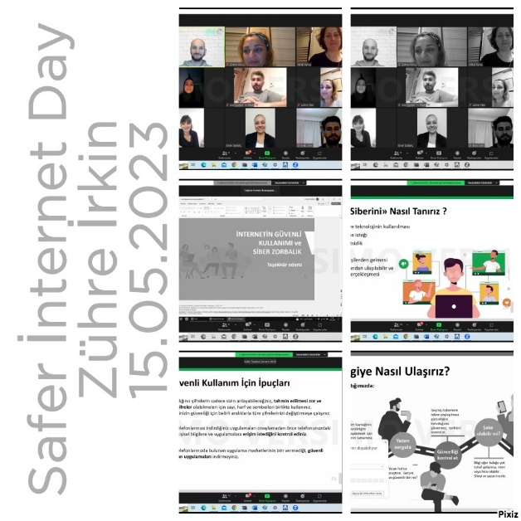

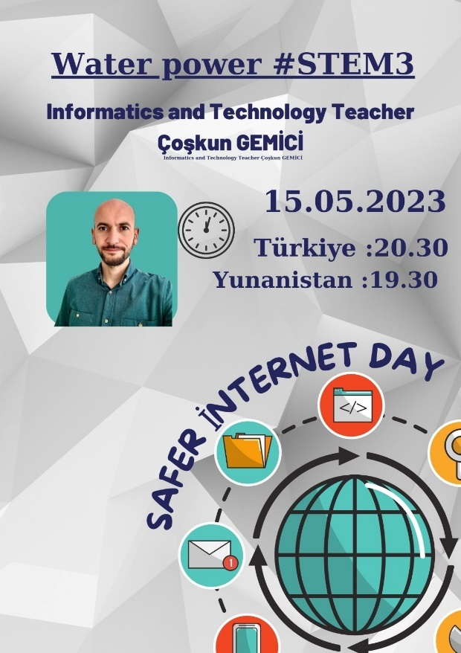

SAFER INTERNET DAY(8 FEBRUARY 2022)

SCHOOL BOARD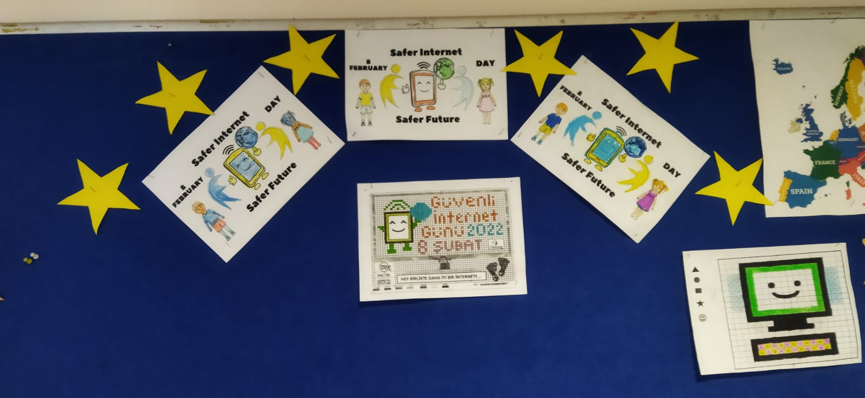

SAFER INTERNET DAY(7 FEBRUARY 2023)

SCHOOL BOARD

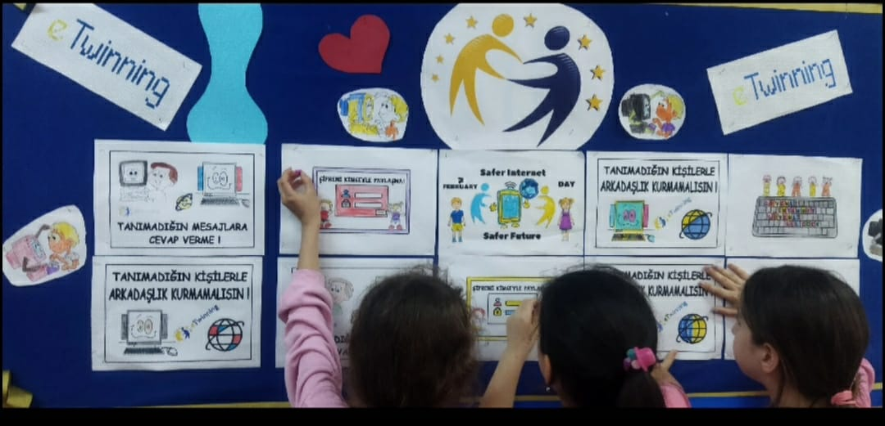

SAFER İNTERNET DAY(13 FEBRUARY 2024)

SCHOOL BOARD

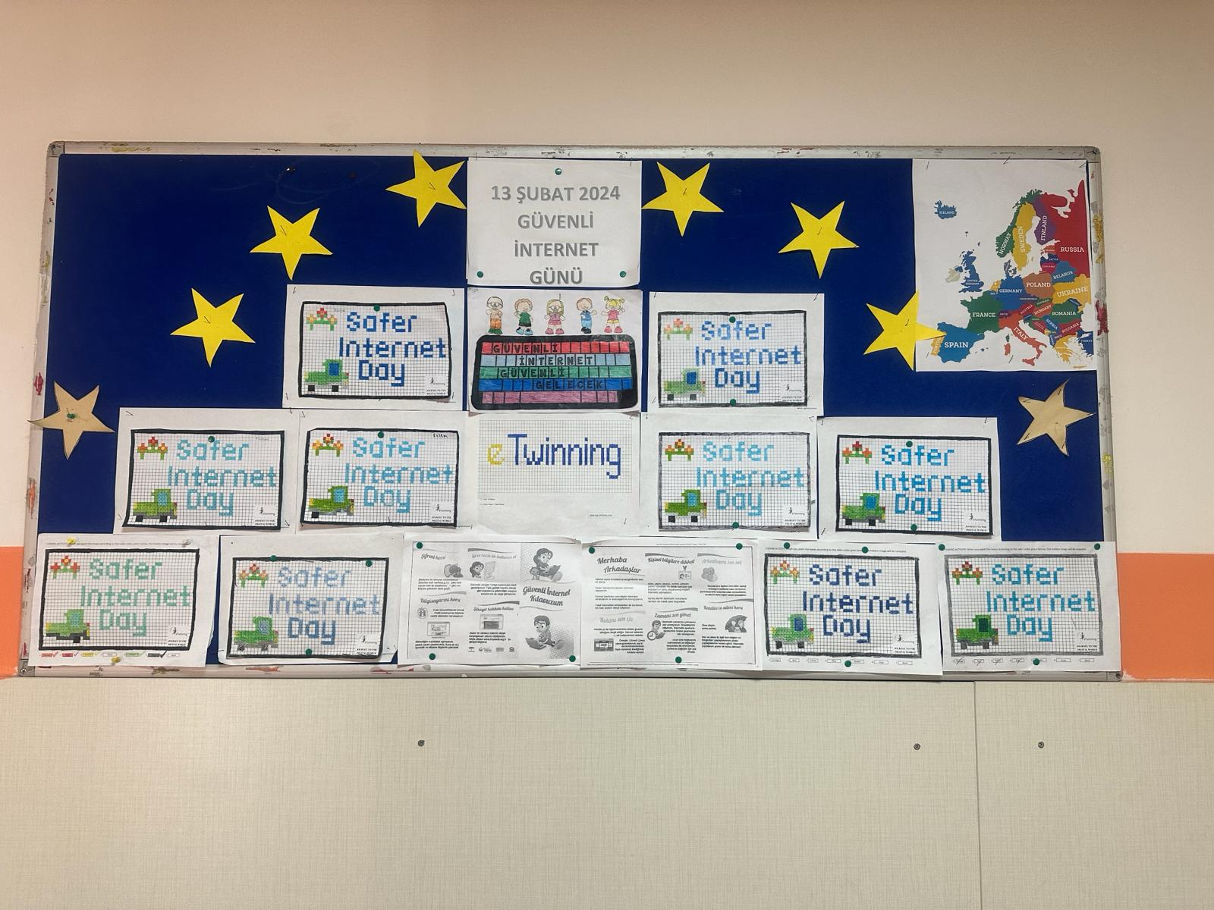

CLASS BOARDS(7FEBRUARY 2023)

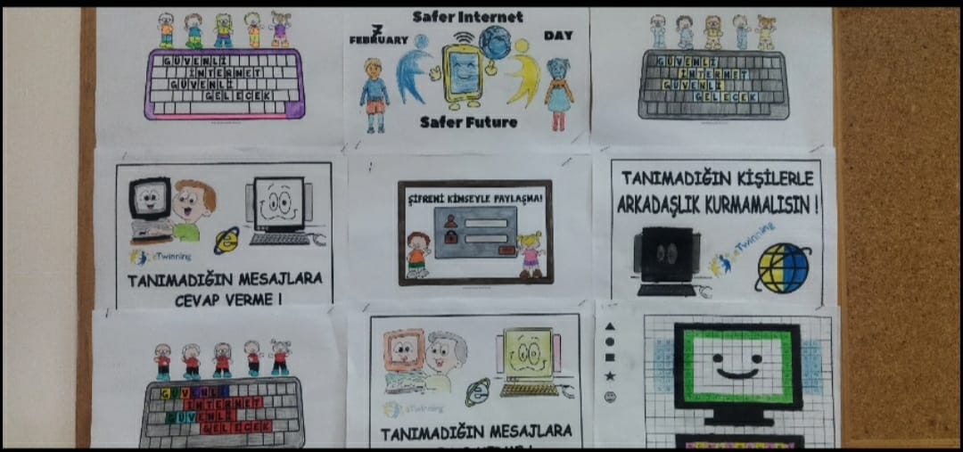

SARER İNTERNET DAY (13 FEBRUARY 2024)

CLASS BOARDS

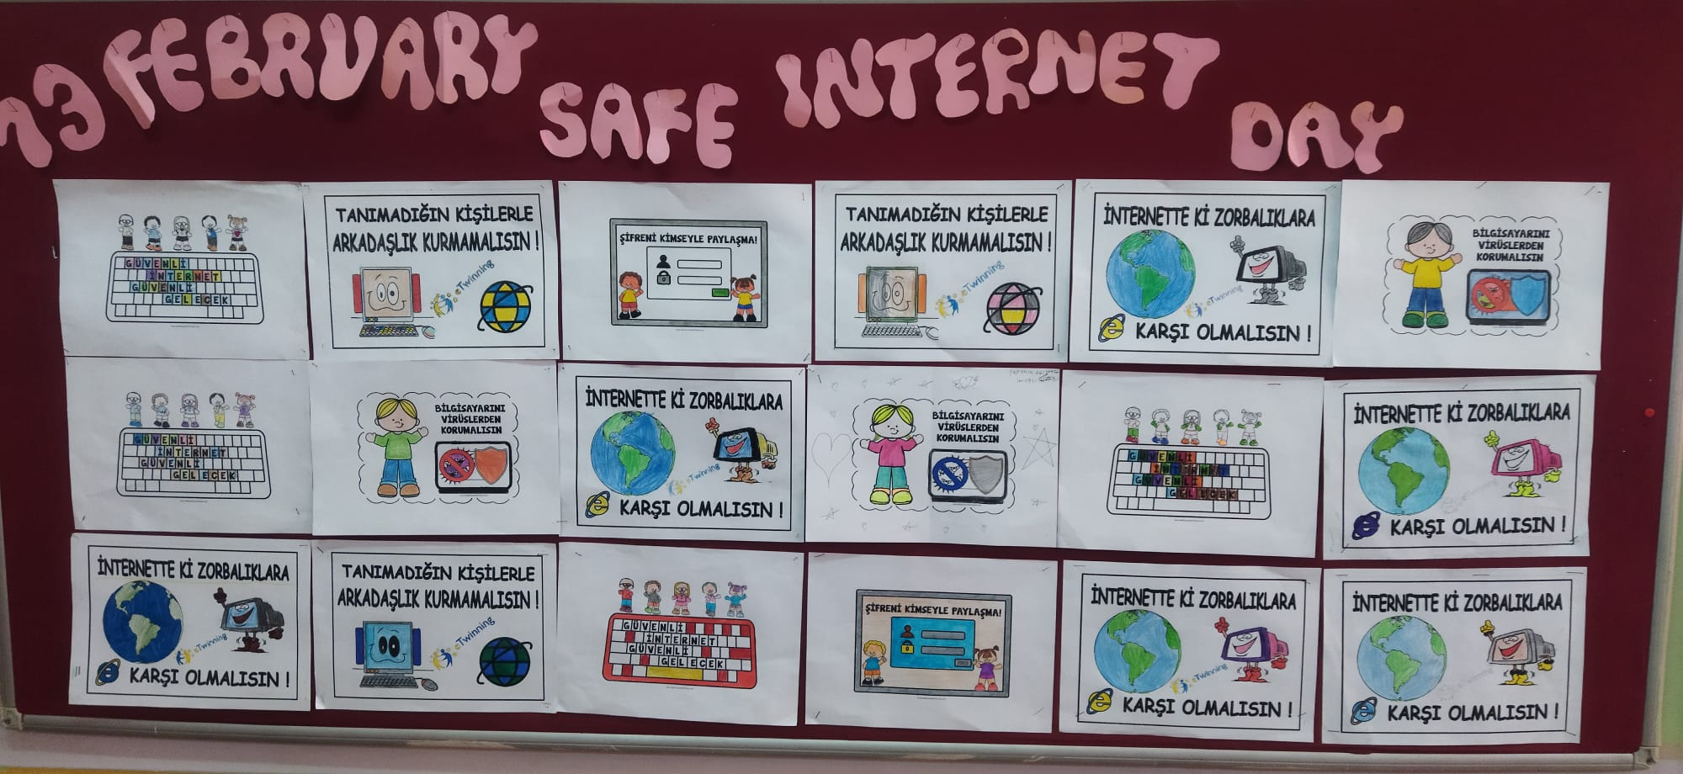

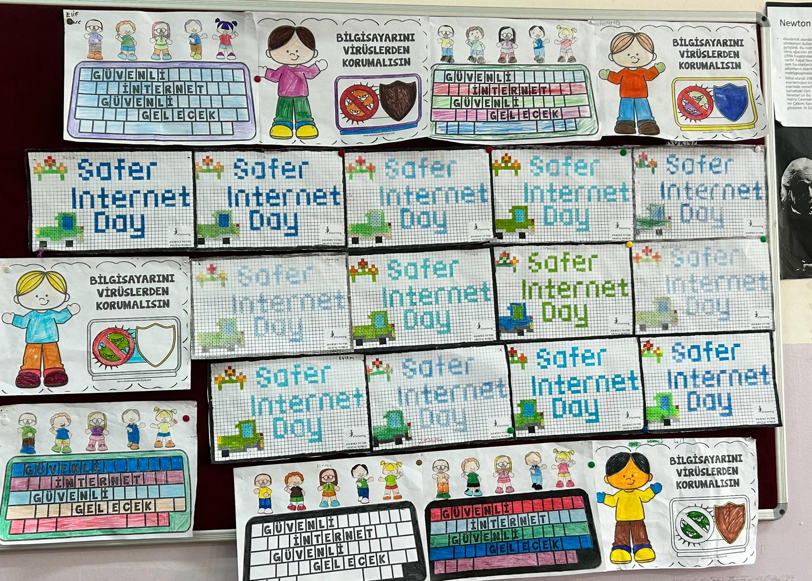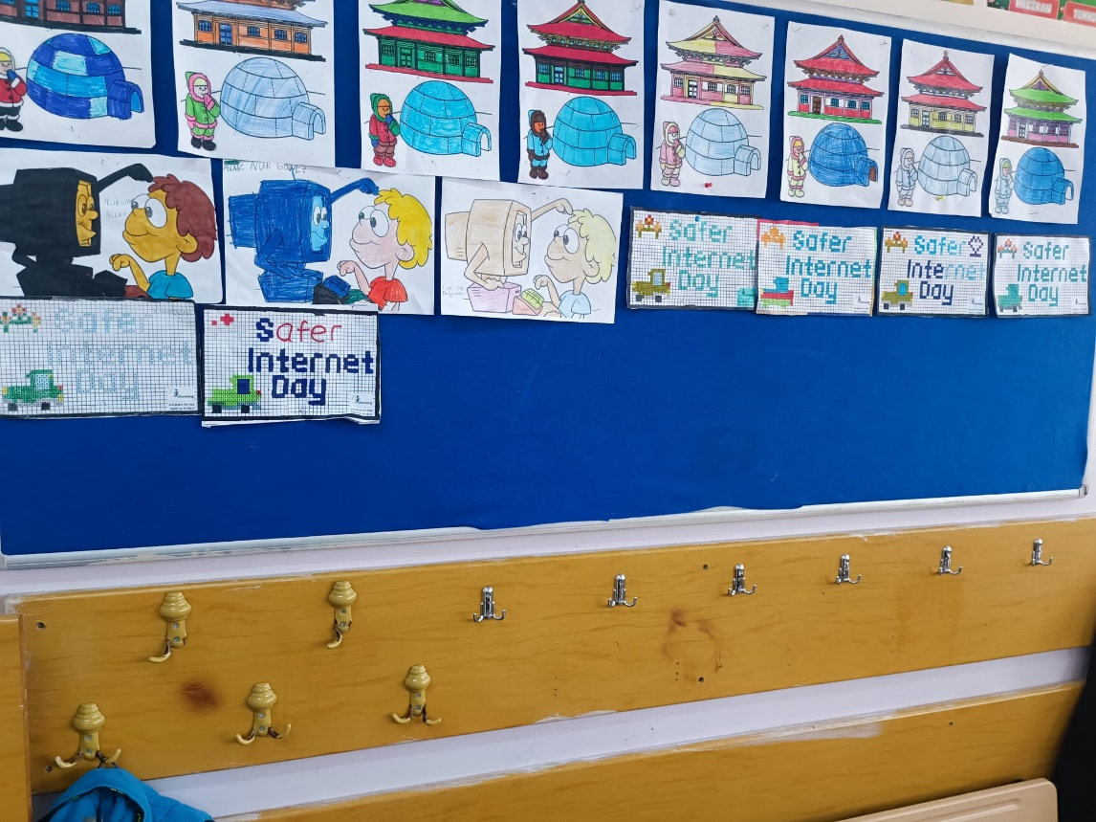

Associating the safe internet day the curriculum
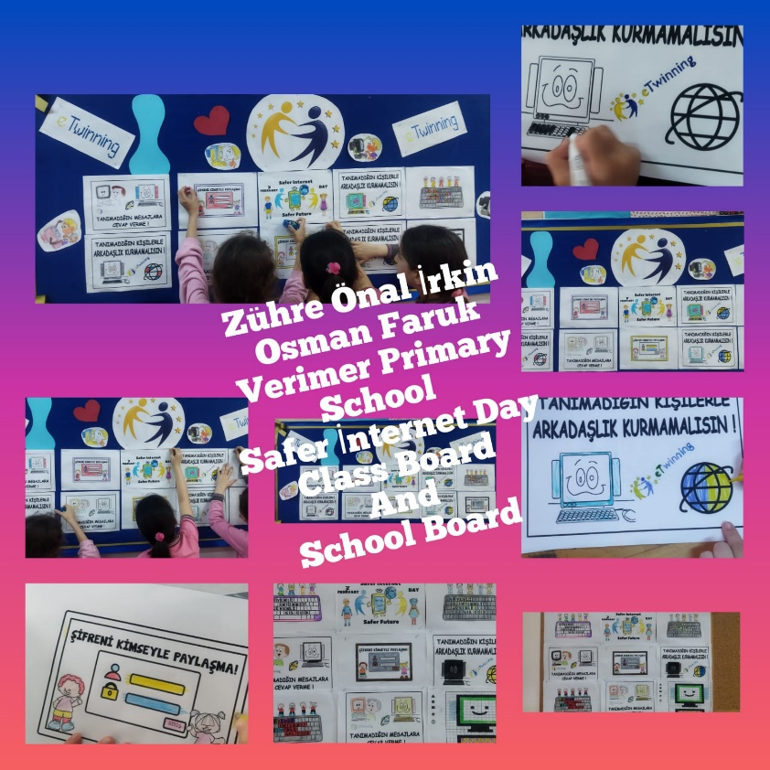
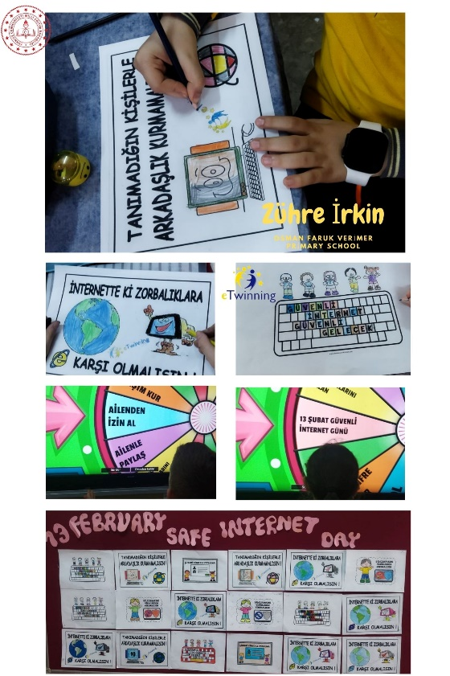

safer internet day board events

FEBRUARY 2024 SAFER INTERNET DAY
Code Activities

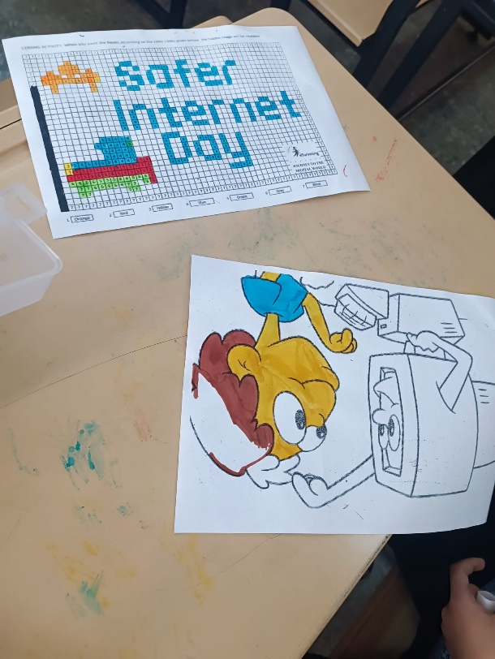

AN EVENT WAS HELD ON CODEWEEK PLATFORM REGARDING SAFE INTERNET DAY, 13 FEBRUARY - 29 FEBRUARY
Safe internet day code week attendance students and teacher certificate
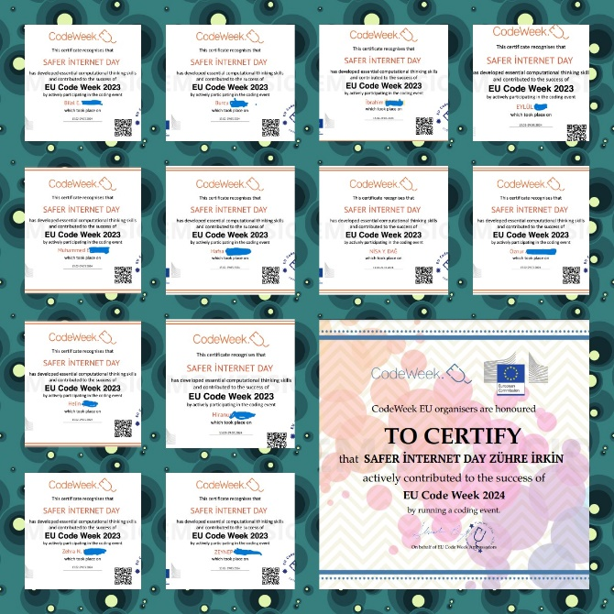
Teacher Participation Certificates We Received from the Codeweek Platform with the Activities We Keep for Safe Internet Week
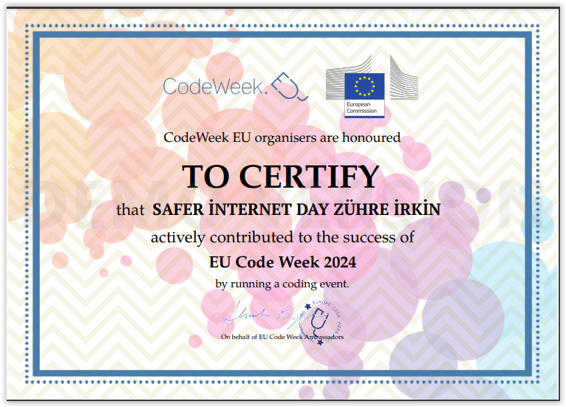
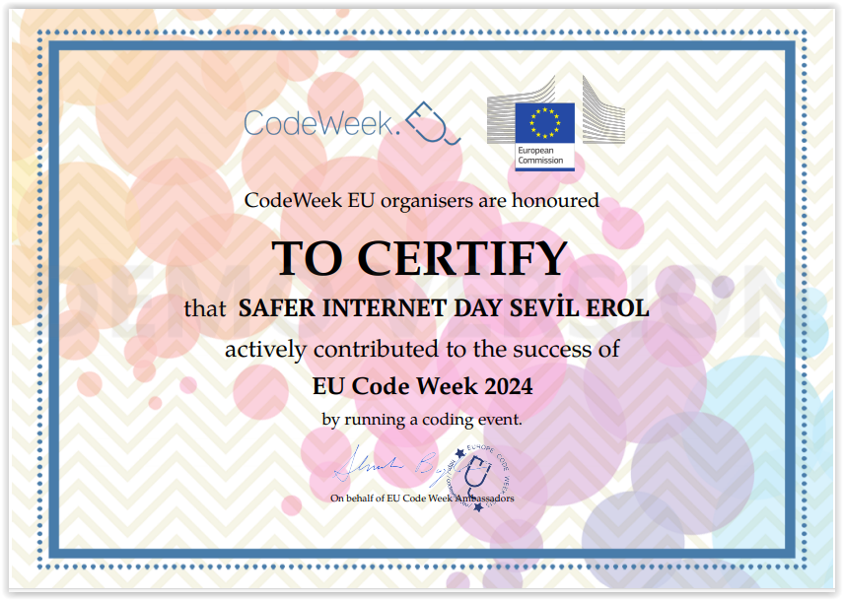
Internet Safety and eTwinning Ethics Course Teacher Documents

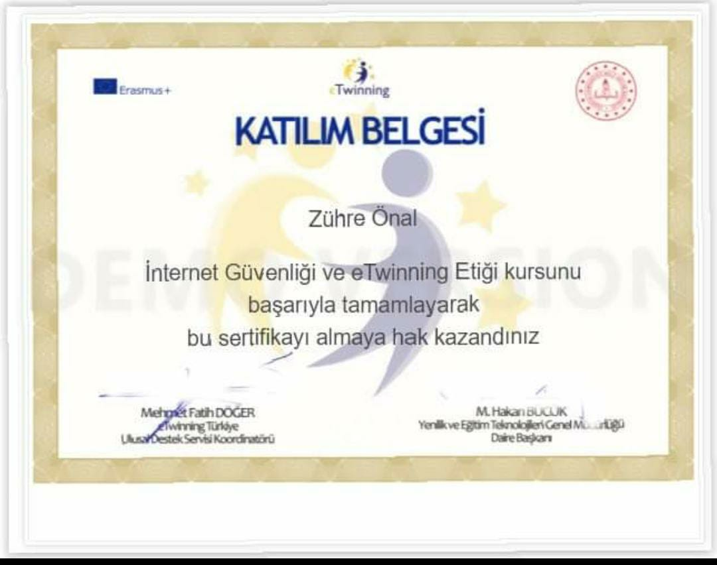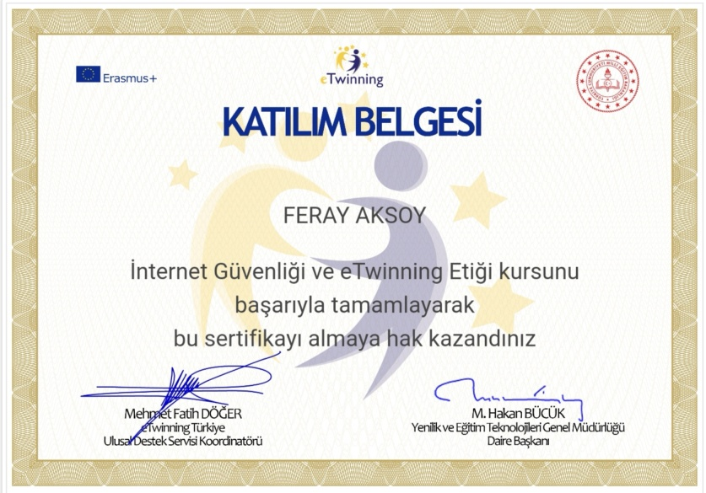

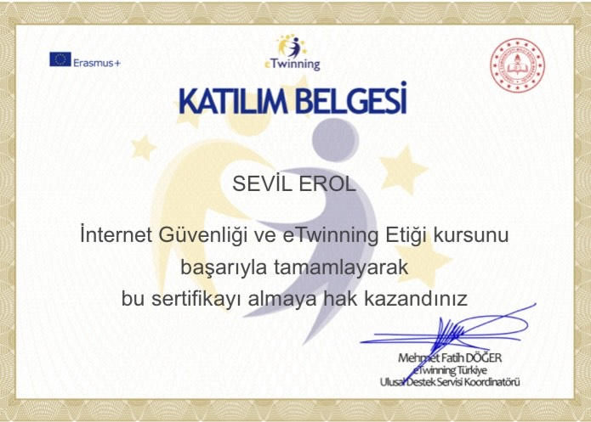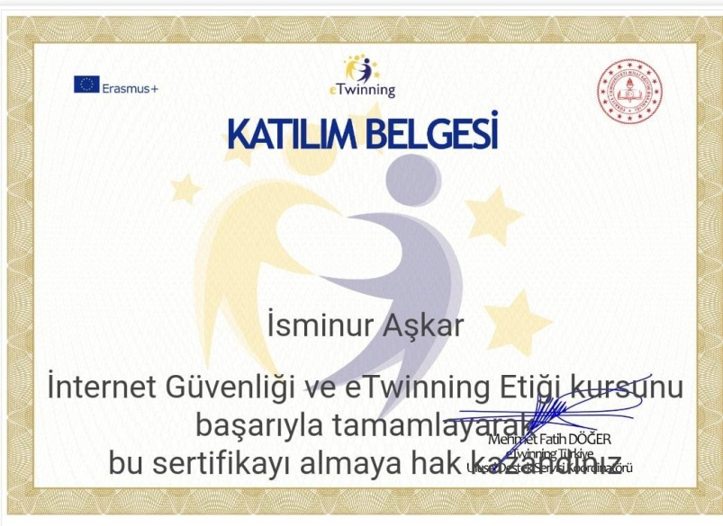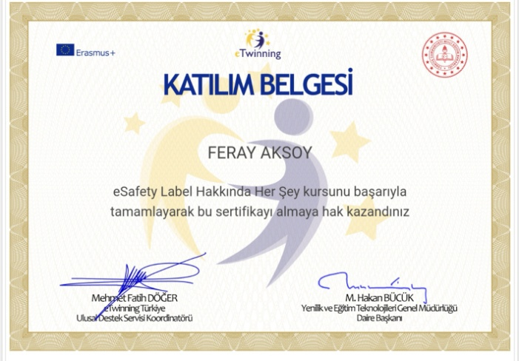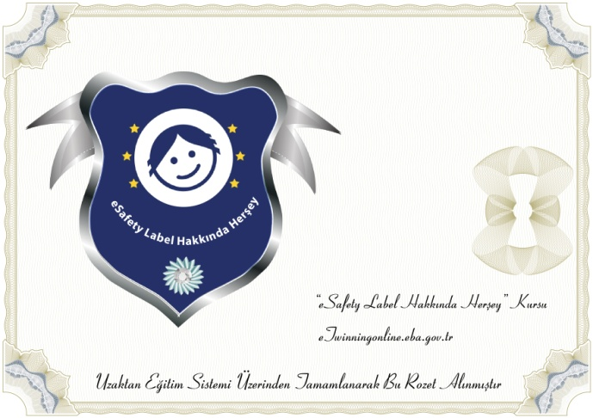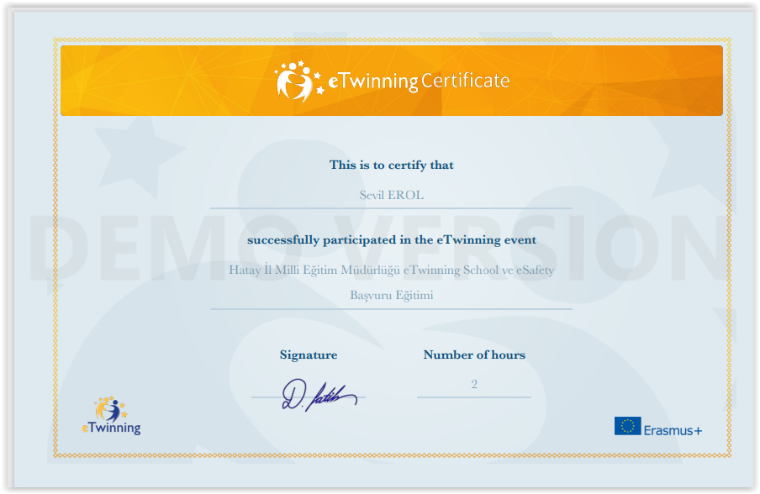

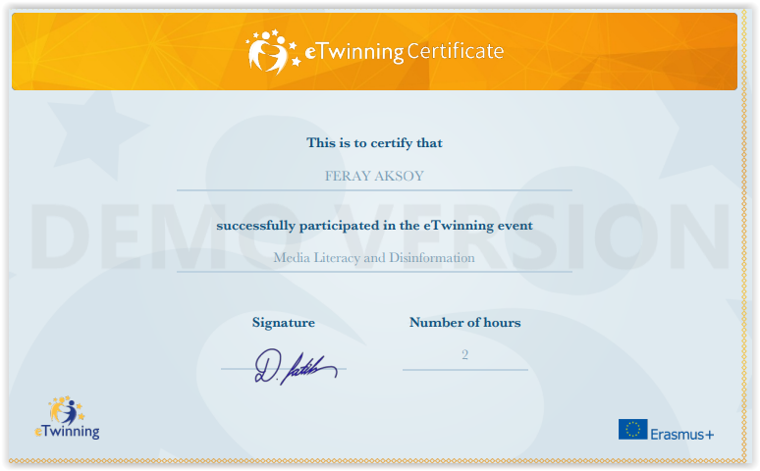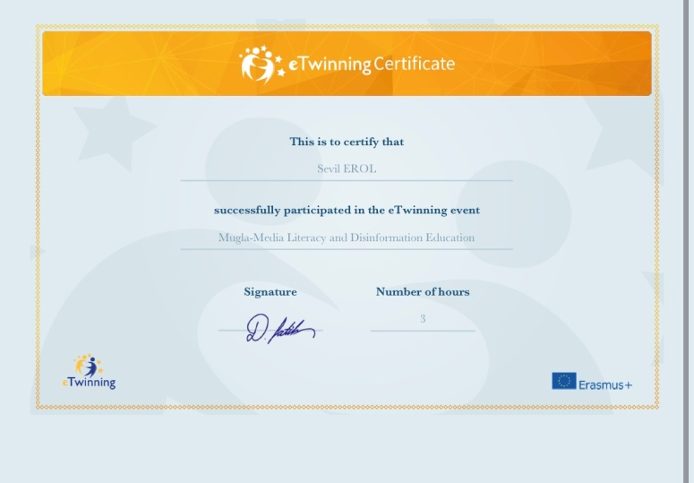

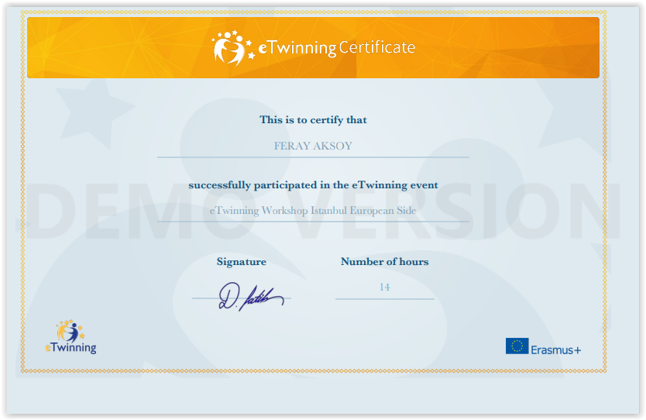

OSMAN FARUK VERİMER PRİMARY SCHOOL’S
E-SECURITY EVENTS 2023/2024

On March 4, 2024, Sevil EROL, our school's guidance counselor, organized a seminar for our parents on "Being a Parent in the Digital Age and Safe Internet Use".
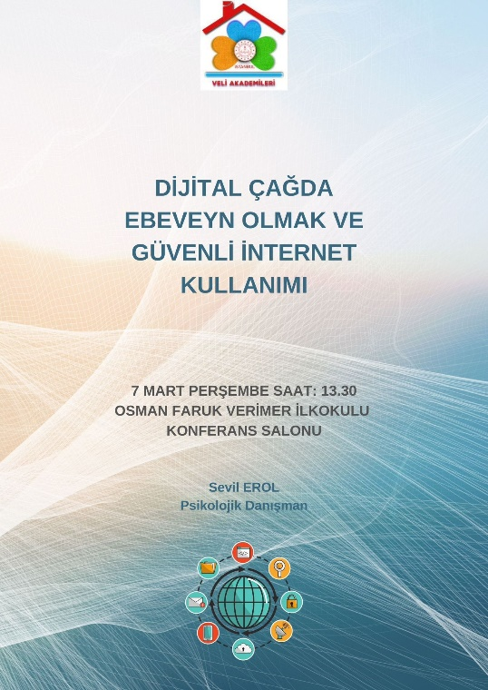

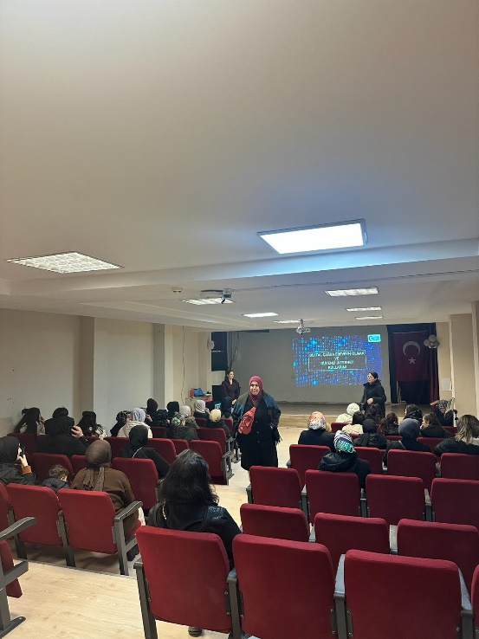

In the minutes of the Osman Faruk Verimer Primary School 2023-2024 Academic Year Beginning of the Year Teachers' Board Meeting Decisions, the article of planning the work to be done at the school by creating an e-Security Board has been added and the work continues.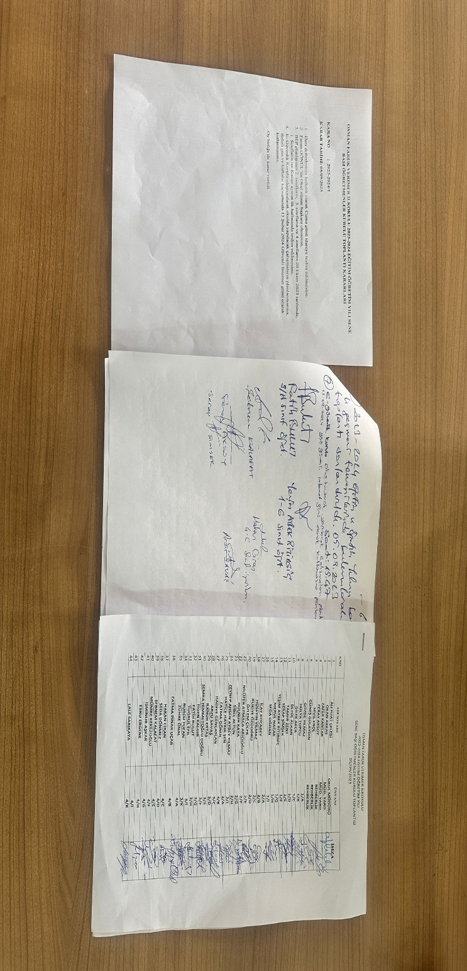

In the Minutes of the 2nd Meeting of the Osman Faruk Verimer Primary School PRD Services Executive Commission, the decision was taken for the planned work on "E-security and Safe Use of the Internet"
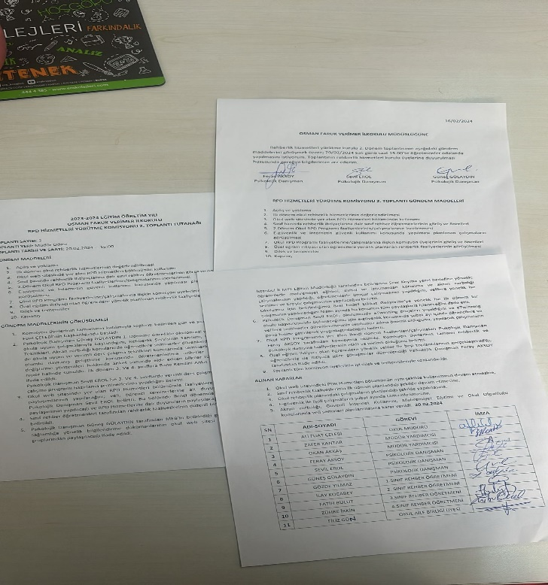

In our school's group meetings, decisions were taken regarding the development of our e-safety policy, organizing events on Safer Internet Day and cooperating with the eTwinning Teacher Team in European School applications.

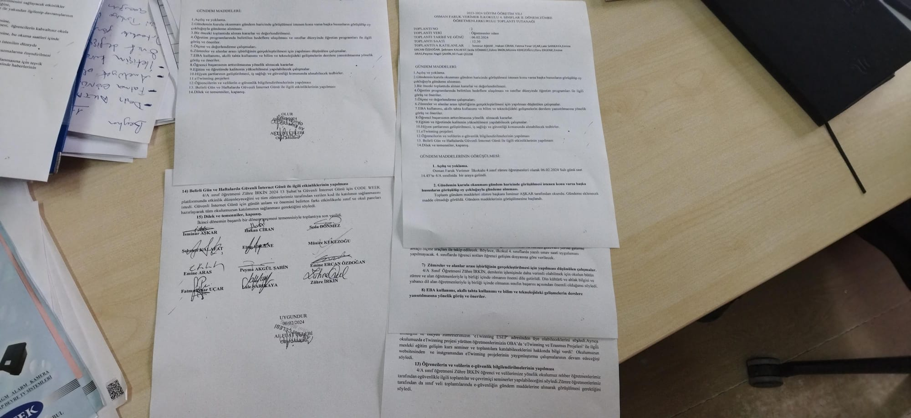

eTwinning School Meeting Minutes 2023-2024 academic year
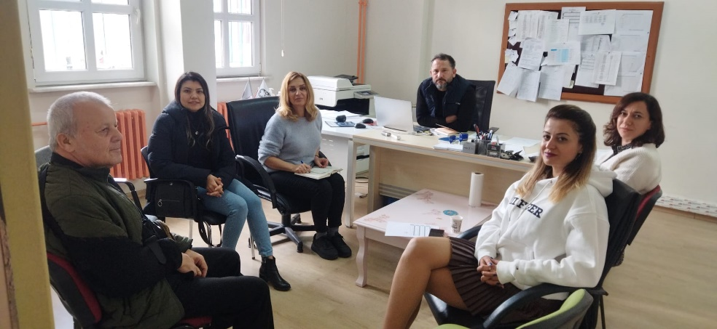
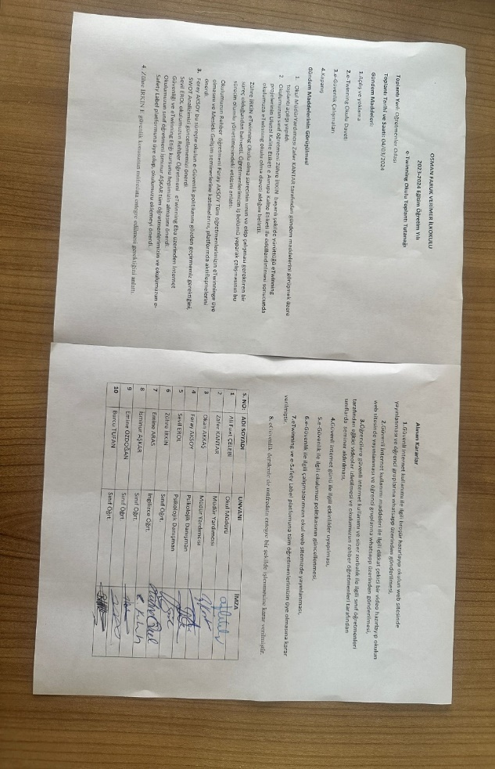

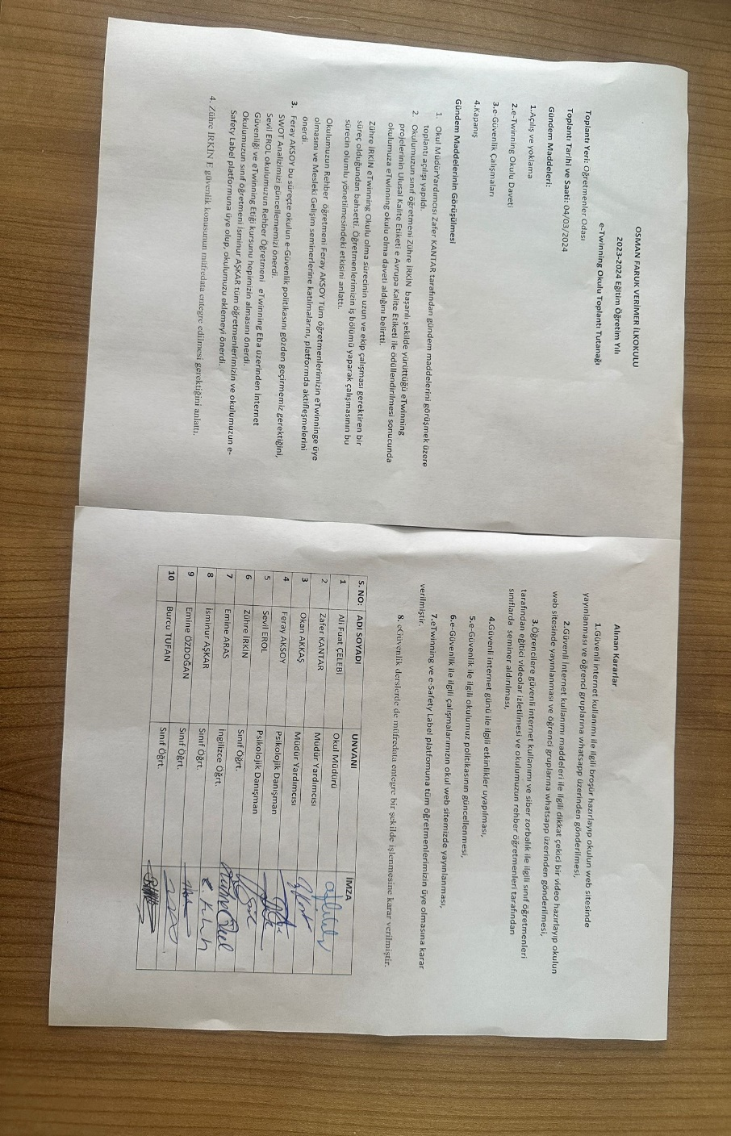

WE HAVE MADE OUR APPLICATION FOR THE E-SAFETY LABEL. WE ARE WAITING TO RESULT. WHEN THE
RESULT IS ANNOUNCED, OUR E-SAFETY LEVIL WILL BE PUBLISHED ON OUR WEBSITE
http://osmanfarukverimerilkokulu.meb.k12.tr/

